Minutes of the Shalbourne Parish Council Meeting
Thursday 14th January 2021 at 7.00pm by videoconference

Present: Mike Lockhart (Chairman), Andy Dolan, Carol Fisher, Emma Verey, Dianah Shaw.

- Introduction
The Chairman welcomed those attending.

- Apologies for absence
Apologies for absence were received from Carolyn Bartholomew, Oliver Banister, Minnie Scott Russell and Bob Walker.

- Declarations of Personal and Prejudicial Interests
None

- Formal business
None.

- Wiltshire Council report – Stuart Wheeler
No report.

- Police Report
There was no report. The message from Wiltshire Police (Attachment 1) that in future there would be no police report was discussed. The Neighbourhood Watch co-ordinator currently posts relevant messages on the Shalbourne Neighbourhood Watch Facebook page and there is a high-level report to the Pewsey Area Board. It was agreed that the Chairman would monitor the Wiltshire Police news and the Area Board report and post relevant articles on the village website. It was also agreed that there would be encouragement to join the Neighbourhood Watch. The Chairman will also write to Wiltshire Police and suggest an officer attends the annual Parish Assembly.

- Minutes of previous meetings
It was proposed, seconded and agreed that the Chairman should be authorised to sign the minutes of the meetings held on 20th November 2020.

- Matters Arising
Dealt with elsewhere.

- Speed Survey Fosbury to Oxenwood
Improvements to the signage on the A338 at its junction with Mill Lane were expected to be completed very soon. CATG has agreed to keep the issue of speed limits in Fosbury and Oxenwood on the agenda until Fosbury becomes part of the Pewsey Area in May.

- Committee Reports
  - Planning
    - The responses to: 20/09881/FUL; 20/09780/LBC; 20/10538/FUL were noted.
    - 20/10669/FUL; It was agreed that there would be no response. 21/00167/TPO: It was agreed that there was no objection to this application but a reminder that these trees are subject to a TPO would be appended to the response.
  - Rights of Way
Nothing to report.
  - Highways and surface water
The priority list for Parish Steward was agreed, see Attachment 2.
  - Local Transport
Nothing to report.
  - Police Liaison and Neighbourhood Watch
Nothing further to report, dealt with under [9] above.
  - Environmental matters
It was agreed that the PC will consider applying for a TPO with each future planning application that involves tree management, depending on the circumstances.
  - Education
The village school has been working very hard through the current lockdown and it was noted that the village should be very proud of their efforts. 13 children are attending school currently with the remainder being taught remotely. The school is also providing free school meals to eligible children via their normal caterer
  - Shalbourne Club Liaison
The Club is currently in lockdown but provides a Covid secure pick up point for local takeaways on Tuesday and Friday

- Finance
  - It was proposed, seconded and agreed that the following grants should be made:
    - Churchyard maintenance - £700
    - Grass cutting - £1632
    - Hall hire - £17.5
  - The balances after the above, Attachment 3, were noted.
  - It was noted that our grass cutting contractor, Last Landscape, had said that it would not increase its rates for 2021. In view of the situation, it was proposed, seconded and unanimously agreed that Last Landscaping should be contracted to cut the grass on both greens in Shalbourne, the play area and the green at Oxenwood in 2021.
  - The proposed budget, Attachment 4, was discussed. After debate, it was proposed, seconded and agreed that:
    - The budget for 2021/22 as set out in Attachment 4 should be adopted;
    - Wiltshire Council should be requested to collect £9000 as precept for 2021/22;

- Correspondence and Any Other Business
  - The statistics for the website were noted;
  - The next full meeting will be on Thursday 18 March.

The meeting finished at 7.37pm

ATTACHMENT 1

From: Edwards, Gareth <Gareth.Edwards@wiltshire.pnn.police.uk>
Sent: 15 December 2020 11:29
To: mikewlockhart@googlemail.com
Subject: Parish/Police Contact

Good Afternoon Mike.
I have been speaking to Richard Rogers today in relation to an number of items.
He has brought the below e-mail to my attention from yourself.

If I may address the issue raised with Officers/Pcso attending Parish council meetings.
I have a limited number of staff to carry out a large number of duties that are placed upon us.
Devizes Neighbourhood Police cover three towns all with their own concerns. i.e Marlborough, Pewsey and Devizes.
A few months ago I decided to stop staff completing parish council reports as we had even fewer staff at that time.
My staff were spending a large amount of time compiling reports such as parish council, Area Board, Town councils.

I had to take a an approach towards all Parish Councils as we cannot attend every Parish council and produce a report for each.
I am sure that you will agree that whilst they are completing reports they are not and about.
We try and do as much as we can with the staff and commitments placed on us.

The Pcc had made clear that he wants the Area Board reports to be completed every month. This is what is being done.
Within the Area board report we have been focusing on the actions for our Priorities.
However I do very much take your point around there being a lack of more local issues and crime trends and will rectify this for January Area Board reports.

I have had to take the stance across all parishes which I know will cause concern and unpopular, but we are unable to sustain this commitment.
In relation to dog thefts we have recently put out information On Our facebook sites, and recently been mentioned in the Swindon Avder.
Crimes such as this we will include in the reports.

I am more than happy to discuss further if you wish.

Regards
Gareth Edwards
Sgt
Devizes Pewsey and Marlborough.

#We are concerned about the breakdown in the liaison between the policing teams and the local community. We are aware that this could be considered a matter for the Police and Crime Commissioner but consider that the situation is now so critical that it should be of concern to the Unitary Council.
Ten years ago, a police officer or PCSO attended at least every other Parish Council meeting, three times a year. In Shalbourne, the agenda was set so that he/she did not have to wait around and could get away after ten or fifteen minutes. Up to about five years ago, a constable or PCSO would attend and speak at the annual Parish Assembly. For the past five years, there has been no police input to any village meeting. During the same five year period, relevant written communications have dwindled to essentially zero. Parishes used to get a report every two months detailing local crimes and actions being taken. All there is now is the police report to the Pewsey Area Board which is not specific and of no value in terms of local affairs.
Shalbourne has had crimes which have affected individuals but have also caused concern to the community. One lady was subject to serious verbal assaults when photographing a car which had, probably, been involved in hare coursing. Currently, there are reports of dog thieves operating in the area. In both these cases there has been no attempt by the police to communicate with the wider community.
There are many ways by which the police could communicate effectively with the local community about local concerns, they should be encouraged so to do.

ATTACHMENT 2

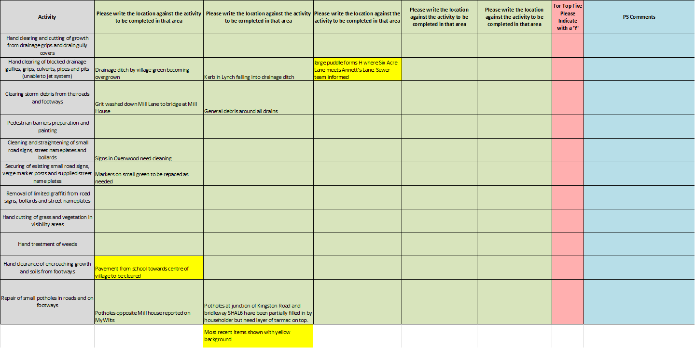

ATTACHMENT 3
Balances following Meeting

- Current Account

Payment Receipt Balance

Balance after meeting of 19 Nov |  |  | 13238.45
Churchyard Maintenance | 700 |  | 12538.45
Grass cutting | 1632 |  | 10906.45
Hall hire | 17.5 |  | 10888.95
Grasscutting |  |  | 10888.95
Balance after meeting of 14 Jan |  |  | 10888.95

- Deposit Account
Payment Receipt Balance

30-Sep-20 | Interest |  | 0.02 | 2583.37
30-Oct-20 | Interest |  | 0.02 | 2583.39
30-Nov-20 | Interest |  | 0.02 | 2583.41

- CIL Account

Balance - £772.60

- Commitments

CATG, Mill Lane turn signage - £156.75

- Bank Balances

Current Account at 4 Dec 20 - £ 13738.45
Deposit Account at 4 Dec 20 - £ 2583.41

ATTACHMENT 4
Budget and Precept
Error! Not a valid link.
 | Agreed Budget 2020/21 | Actual 2020/21 to Jan 21 | Projected Out turn 2020/21 | Budget 2021/22
Hall Hire | 250 | 18 | 125 | 250
Telephone/Postage | 10 |  | 10 | 10
Insurance | 400 | 237 | 237 | 400
Speed limits, contributions to CATG | 600 | 0 | 200 | 600
Village events | 700 | 0 | 300 | 700
Chairman's Expenses | 100 | 39 | 39 | 100
Training | 100 | 0 | 0 | 100
CPRE | 120 | 36 | 36 | 120
WALC/NALC | 220 | 199 | 199 | 220
Community First | 45 | 40 | 40 | 45
Grass and tree cutting | 2750 | 1360 | 1360 | 2750
Christmas Tree | 200 | 140 | 140 | 200
Defib Shalb Conn | 1400 | 1054 | 1054 | 1400
Play Area inc net TT | 2000 | 905 | 905 | 5300
Village Website, DP reg | 150 | 177 | 177 | 150
Village Hall | 1000 | 0 | 1000 | 1000
Misc Small Grants | 400 | 500 | 500 | 1300
Churchyard | 800 | 700 | 700 | 800
Notice Boards,posts, bins | 300 | 0 | 0 | 300
Total | 11545 | 5405 | 7022 | 15745
VAT Reclaimed,
Rental Income
CIL Income,
 |  | 2021/2022
Budget |  | 15745
Contingencies or working balance |  | 4500
Total Required |  | 20245
Balance at Jan 21 less CIL |  | 12699
Expenditure before y/e |  | 1617
VAT receivable in 20, 21 |  | 0
Funded through CIL |  | 0
Precept required |  | 9162

Impact on Council Tax

Year | Taxbase | Precept | Total  £ for Band D | Difference in £ for Band D | % change on last year for Band D
2020/21 | 330.10 | £9,000.00 | £27.26
2021/22 | 316.15 | £9,000.00 | £28.47 | £1.21 | 4.44%
To show the change across all Bands:
Year | A | B | C | D | E | F | G | H
2017/18 | £9.23 | £10.76 | £12.30 | £13.84 | £16.92 | £19.99 | £23.07 | £27.68
2018/19 | £16.09 | £18.78 | £21.46 | £24.14 | £29.50 | £34.87 | £40.23 | £48.28
2019/20 | £17.23 | £20.11 | £22.98 | £25.85 | £31.59 | £37.34 | £43.08 | £51.70
2020/21 | £18.17 | £21.20 | £24.23 | £27.26 | £33.32 | £39.38 | £45.43 | £54.52
2021/22 | £18.98 | £22.14 | £25.31 | £28.47 | £34.80 | £41.12 | £47.45 | £56.94
Difference for each Band £ | £0.81 | £0.94 | £1.08 | £1.21 | £1.48 | £1.74 | £2.02 | £2.42
% difference for each Band | 4.46% | 4.43% | 4.46% | 4.44% | 4.44% | 4.42% | 4.45% | 4.44%

